FLOCK BLOCKER
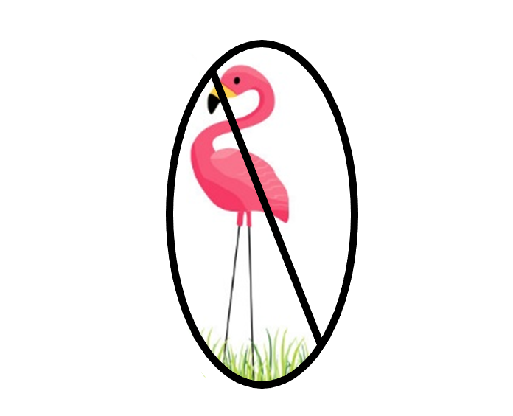
Insurance $20

The Purchase of this Flock Blocker Insurance guarantees that no flock of flamingos will roost on your lawn as they migrate around the city during
the course of this fundraising event, August 24-Oct. 25th.

Policy Holder Name: ___ _________

Policy Holder Address: ___________________ ______

Thank You For Your Support!
The Band Boosters is a 501(c)(3) charitable organization.

FLOCK BLOCKER
Insurance $20

The Purchase of this Flock Blocker Insurance guarantees that no flock of flamingos will roost on your lawn as they migrate around the city during
the course of this fundraising event, August 24-Oct. 25th.

Policy Holder Name: ___ _________

Policy Holder Address: ___________________ ______

Thank You For Your Support!
The Band Boosters is a 501(c)(3) charitable organization.

